**Neural Networks & Deep Learning - ICP-9**

**Git Hub Url:**

**https://github.com/Lakshminarayana008/Demo**

**Program 9:**

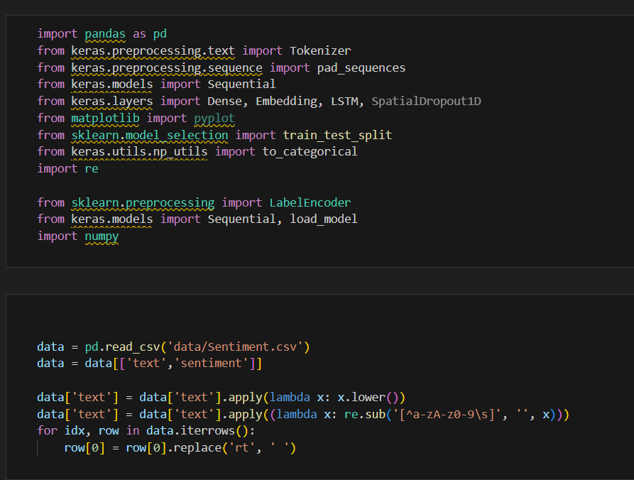

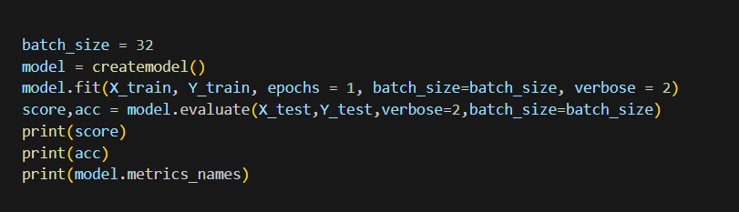

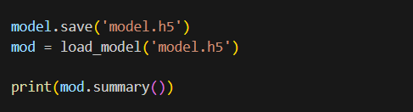

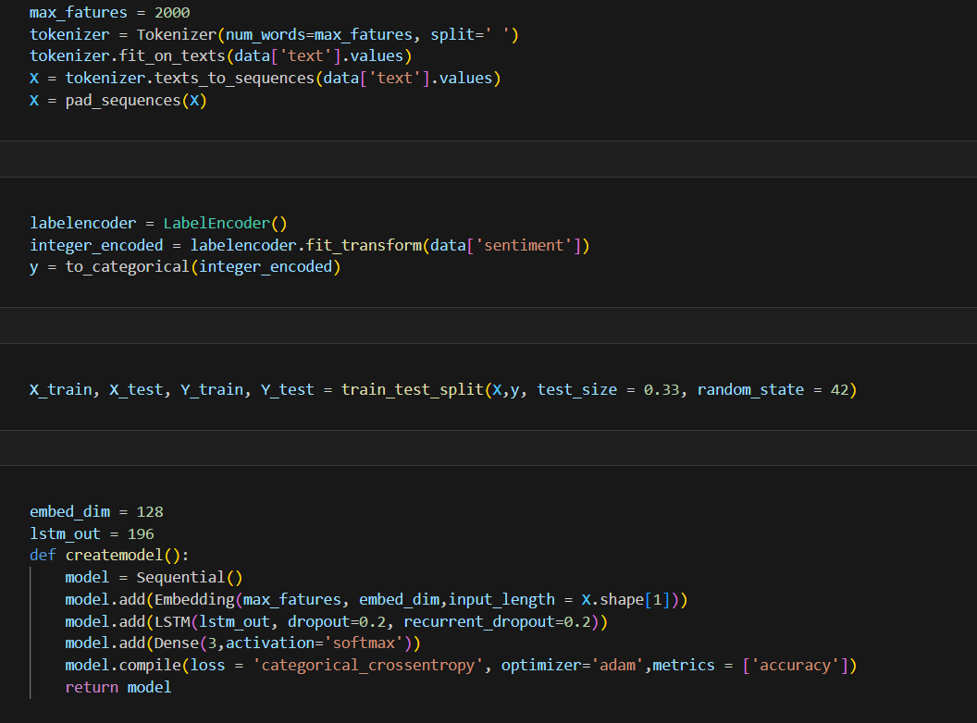

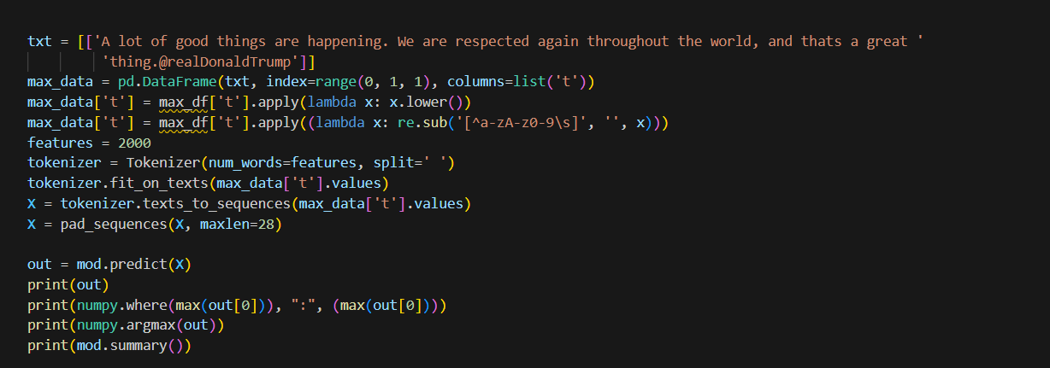

**Output:**

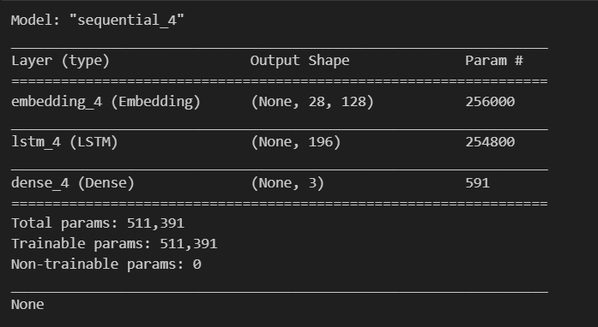

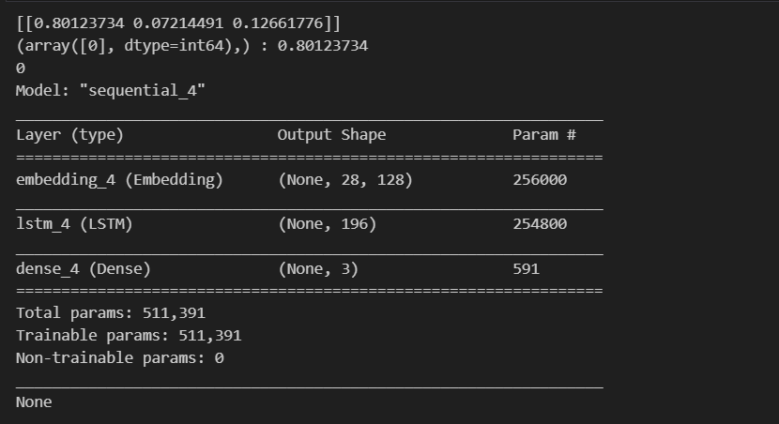

**Program 9.2:**









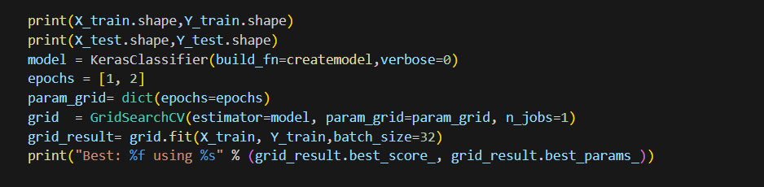

**Output:**

